CPS 824 Reinforcement Learning – Assignment 01

1. A)

The optimal policy must be set to a value of rs= -1 to find the shortest path. If the policy was set to rs=+1, then the agent may just repeatedly go between squares over and over to generate a high reward, gaining +1 for every square traveled. This would have the program run infinitely and risk the green square never being located. Similarly, the next best guess would be to have rs=0 but this could also have a problem. The program may go from square to square without reason, eventually finding the green square but the optimal path may never be found. The program can wander around aimlessly, eventually finding the green square, but it has no way to determine if that path was the most optimal due to the reward of most squares being 0.

If the reward for the basic squares was set to a punishment like rs=-1, the program can find the shortest path eventually. In this approach, the program is getting a penalty for taking longer to get to the green square. After long training the optimal policy should figure out a quick path to the green square from any square without any redundant squares.

Implying rg=+5, rr=-5, γ=1 (no discount on future rewards) and rs=-1 the optimal policy values for the puzzle would look like the following:



*[n] representing terminal squares.*

1. B) If each reward has a +2 to them, the rewards are now: rg=+7, rr=-3, rs=+1. The optimal policy will now have this set of values.

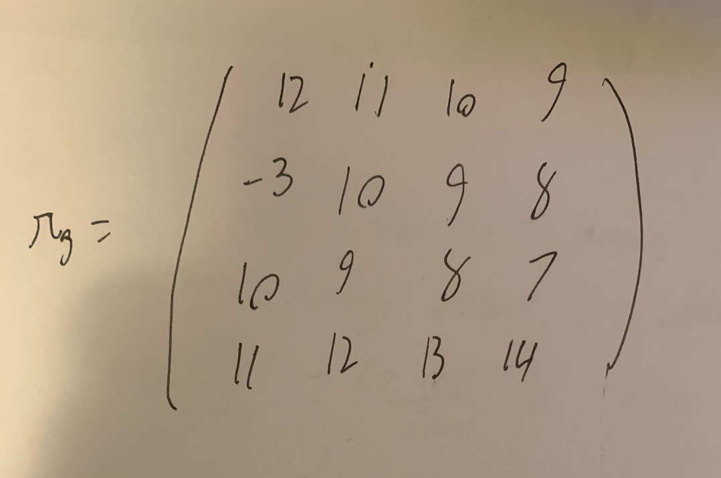

1. D) As mentioned in 1 A), a positive reward (such as rs=2) would potentially cause problems in finding the optimal path. Since the program’s goal is to maximize the current reward, it may constantly go back and forth from squares in order to generate a high reward. This would potentially lead to failure as there is a chance the program never finds the green square.
2. E) Yes, it can change and does depend on the choice of gamma. A small discount factor would eventually find the optimal path to the green square because the rewards in the future would be worth less than present rewards.
3. F) If you chose a comically small reward value like rs=-500, we could end up at the red square because each normal square would yield a reward of -500, while the red square would yield a reward of -5. Since the program’s job is to maximize the reward, it will eventually form a path to the red square.